Walk 4: Dalton Bank Circular
[Approx 7.5km/4.75m ]
St John's - Hillside - Bankfield - Wellhouse - Dalton Bank - Upper Heaton - Hollin Hall- Upper Hopton - Cockley Hill - Laneside - St John's
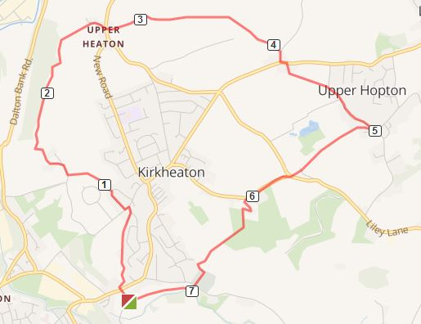
1. Start at the side entrance of the church and walk up Church Lane to the main road. Cross the road and follow the footpath sign into the old school yard and up the stone steps. Continue along this path until it meets a lane. Turn left and go up the hill behind house until it brings you into Stead Lane. Continue left onto Bankfield Lane. Just after the convenience store turn right into Bankfield Avenue. Continue along here until you see a path between houses on the left [sp] which takes you out into the fields.
2. At a crossroads of paths continue down the hill going between houses onto the road at Well House. Turn right here and follow the road until it is blocked by a gate leading to a carpark on Dalton Bank [At the moment - Oct 2009 -this gate is locked] From here numerous paths lead across Dalton Bank with long distance views over industrial Huddersfield.
3. Continue along the Bank following the contours [past the graphitised rock faces] until the paths merge into just one hugging the top of the Bank. The path forks at a stone wall on the right. Follow the right hand path keeping the wall on your right down into Upper Heaton. Cross the road and follow the footpath sign across a field to a stile. Continue across 2 field to a hidden stile at the top end of the last field leading into a farm lane [could be very muddy here- see #alternative route]
4. Turn right up the lane and follow the track through a field over a stile and through 2 other fields. The path leads onto a tarmaced farm track. Cross the track and go over a stile [sp] Go diagonally left up the field through a gate and continue on the same line to a gap in the top left corner [sp] This leads into Hollin Hall. Turn right here and go to the main road. Turn left and after a few metres cross the road to follow the footpath sign around a house and through field to reach Upper Hopton [Take care to go right over a stile halfway along this path and then keep the hedge on your left to get to the road into Upper Hopton]

