Walk 5 Whitley Estate Circular
St John's - Laneside - Cockley Hill- Upper Hopton - Lower Hopton - Whitley Lower/Charlotte's Ice Cream Parlour - The Temple - Houses Hill - Whitley Willows - Gawthorpe - Lascelles Hall CC- St John's [approx 11.5km/7 miles]

A varied walk touching the outskirts of Mirfield with good views over to Dewsbury and Huddersfield

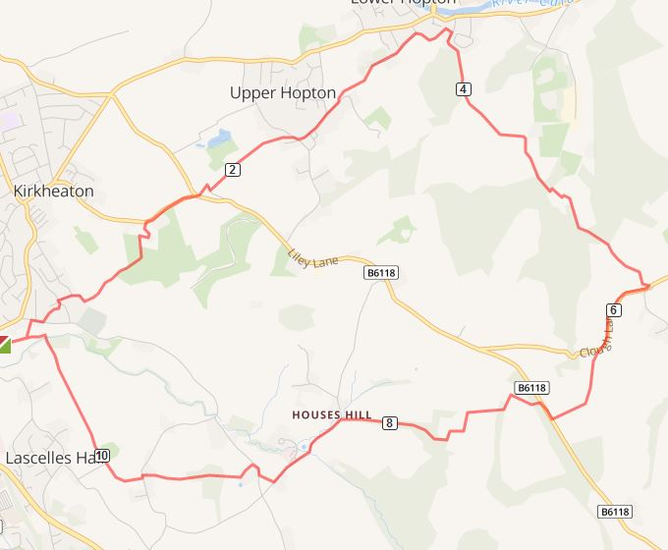

1. Start at the side gate of the church opposite the Beaumont Arms. Cross the road and follow the green lane by the back of the Beaumont [sp] Go through the gate and immediately turn left following the wall up the field to a gap between houses leading into Laneside.
2. Turn right, cross the road and after about 60 m turn left up a path [sp]
Follow the path up the hillside until it comes out onto a tarmaced road [Stafford Hill Lane] cross and go along Mountain Way. At the second footpath sign turn left up through the trees and walk up the hill following the line of the Landfill fence.
3. Where a footpath joins in from the left climb the stile in front [or go round it - the fence is broken] and continue up the hill following the line of the boundary of the field on your left. Ignore a path through a gateway to the left and continue up the hill to a small gap on the left [yellow arrow] and continue up the next field, over a stile into the field adjacent to a house.
4. At the top turn right and go through a white gate. Follow the house drive to the left and immediately after the main gate turn right up a flight of steps on to Cockley Hill.
Continue right up to the junction with the road [B6118] Cross this and follow a gated lane in front of some houses [sp] After the last farm building immediately turn left down the side and continue across the fields to reach Upper Hopton. Here turn right and cross the road to go down Hopton Hall Lane.
5. Where the road bends to the left continue straight across onto a private road. After about 70 metres turn left onto a footpath [sp] and follow this across 2 fields down to the corner of terraced houses. [Good views of Mirfield and beyond] Continue in front of the house down Hand Bank Lane until just before it joins the main road, turn right [sp] over a stile into a rather muddy field.
Follow the line of the hedge for about 20 m then climb a stile to walk along a narrow path behind some gardens. This zig zags behind houses [yellow arrows] until it eventually turns left into the bottom of a field.
6. Follow the edge of the wood up the field. At the top go over a footbridge in the middle of the field boundary. Continue up the hill ignoring a path going left to right. Go over a stile into the next field and follow the path diagonally to reach a narrow lane.
Turn right here and continue down the lane then up the hill in front of you with a wall on your right [Again ignore other paths coming in from l and r ] Go over a stile to join a bridleway. Turn left and almost immediately right to join a tarmaced road leading to some houses. Turn left in front of the houses and go through a gateway onto a drive. Keep left and the path goes up the hillside.
7. Continue up the hillside. When you come to a wood the path splits - take the left fork through the wood out into the field beyond. Continue up the hillside keeping the field boundary on your right up to the road at Upper Whitley. Within 20 m to your left is Charlotte's Ice Cream parlour if you care to indulge [they sell coffee, food etc as well] Then turn right along the road until it makes a sharp right hand bend and drops down. Here turn left onto a track [no sp but beware of cables notice] Continue along the track which will bring you out on the Grange Moor Road.
8. Cross the road and turn right. Just after the entrance to Temple Quarry turn left over the wall [sp] to go through a plantation. Head for the old folly - Black Dick's Temple with good views over Huddersfield. Then continue along the path to a small stile into the woodland. Follow the steps down to an access road.
Cross the road, go over a stile and walk diagonally through the field left aiming for the corner of a property boundary. Here keep left and walk round the boundary to meet the access road. A few metres further on turn right down a rough track behind a large building. This will lead you to the road at Houses Hill.
9. On reaching the road turn left and follow it past the new development at Whitley Willows to a footpath sign on the right nearly opposite Addle Croft Farm. Cut across this field to reach the road and turn right by Broomfield House. Take the next left path [sp] just after the corner and follow the path diagonally through the field to a wood. Continue up through the wood and over a stile into a field. Continue up to reach a stable yard. Go through the yard to reach the road at Gawthorpe.
10. Cross the road and into the field opposite. Turn right where it meets a path and continue down through the fields past Lascelles Hall CC on your right. Eventually you cross a stream and turn left into the field behind the Beaumont. with the church straight ahead.

