Walk 8: Circular Walk around Upper Heaton
Upper Heaton - Round Hill - Cycleway - Bog Green/Bog Hall - North Moor Lane - Meadow Park -
New Road - Upper Heaton
[approx 4 km/2.5 miles]
A circular walk centred on Upper Heaton and its surroundings
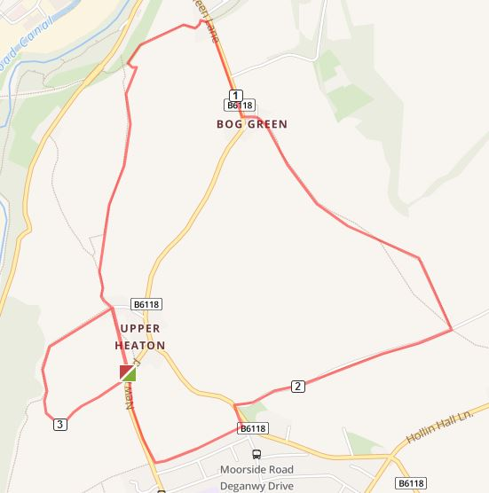
- The walk starts at the broken footpath sign just after the Upper Heaton sign on New Road. Go through the gate and walk through the field to the door opposite. This will take you between some buildings, over a stile onto a farm track.
- Turn left and follow the track downhill through some gates. At a stile in front of you [yellow arrow] leave the track and head uphill to a stile in the middle of a field wall.

- From here walk diagonally right across the next field to the gate and follow the path down keeping the wall on your right.
- Go over a stile [yellow arrow] and join the cycleway. Watch out for silent cyclists! Turn right and follow the track to the road.
- Turn right and climb up the hill to Bog Green. Cross the road and turn left through The Old Farm yard [sp] Follow the yellow arrow to the right behind the houses and go over the stepped stiles into the fields. Keeping the wall on your right go along the field edge to a large gap[sp] and go directly up the hill to a stile
- Walk diagonally left cross the next field to some trees and a yellow arrow marker. Cross into the next field and head up the field to the stile on the farm lane.
- Turn right onto the lane and continue to the main road. Cross the road and walk a few metres down Mooorside Road to the footpath on your right. If this looks a little overgrown, walk a little further down the road and turn right onto Meadow Park. Either route takes you to New Road where you turn right and walk up the hill to complete your circuit.

