Walk 9: A stroll through Kirkheaton using some of the snickets
and right of ways
Old Post Office - Furnbrook Gardens - Stead Lane - Bankfield Ave - Southlands - Stoney Ford Lane - Easingwood - Moorside Road - Heaton Moor Road - Epsom Way - Cockley Hill Lane - Mountain Way - Orchard Road - North Hill Drive - St Mary's Fold/Lane - Post Office
[Approx 4km/2.5m]
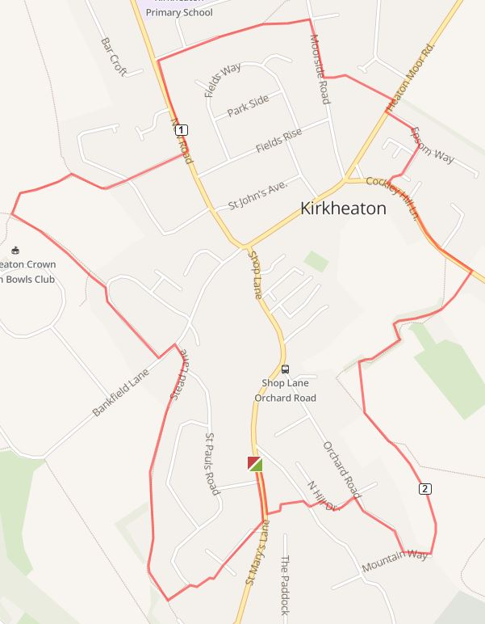
1. This walk starts at the old Kirkheaton Post Office on St Mary’s Lane. Walk down the hill crossing St Andrew's Drive and then turn right up Furnbrook Gardens. Head up to the top left and walk up what looks like a private drive between garages to a hidden footpath onto the 'new' part of St Paul's Road. Keep left, walking past the gated access road onto Stead Lane.
2. Turn right and continue up the unmade lane behind the houses. Eventually the now made up lane bends right and then up onto Bankfield Lane. Turn left and then right onto Bankfield Avenue after passing the shop - Super Saver.
3. Continue along Bankfield Avenue until it starts to bend around to the right. Here turn left onto a footpath [fs] between the houses. Follow the path across the field and turn right at the junction with other paths.
Continue on this path to a T junction just behind houses. Here turn right and follow the path to a road [Southlands] Cross the road onto Stoney Ford Lane and then onto New Road just opposite the United Church.
4. Turn left up New Road and continue up to Easingwood Drive. Here turn right and continue onto the footpath at the end onf the road. Keep right. This path leads onto Moorside Road.
Here turn right and walk down to a footpath sign about 80m on the left. Here turn left and follow a rough path behind some houses. This leads onto Heaton Moor Road.
5. Cross the road and turn into Epsom Way and then right onto Newbury Walk. [odd numbers] Tucked in the corner on the right is a path that will lead you out into Cockley Hill.
Turn left here and go up the hill until you see a footpath sign on your right [next to a house with a white garage door
6. Turn down here and cross the drive to Broomfield House, to a shady path which leads downhill. Follow this down to a stile.
Cross the stile into a field and walk to the next stile ahead. After crossing this make your way diagonally across the next large field towards a wide pathway which continues down the hill to a gap leading onto a tarmaced road
7. Turn right here and continue along Mountain Way. Turn right at its junction with Orchard Road. At the cross roads turn left onto North Hill Drive and as the road bends round to the right turn down a snicket between 2 houses onto Stafford Hill Lane. Cross here and go down the path between the cottages of St Mary's Fold and Lanka Garage. This leads onto St Mary's Lane. Turn right here to complete this circular stroll.

